Introductions:

nearby sensors in IoT which can come out to help the victims.

1. In case of lighter collision, only the local car repairs and other nearby sensors forming an IoT

network will be informed.

2. In case of high intensity collision, the data relating to location of car and other things will be sent to

cloud which will then inform the nearby car repairing showroom, hospital services and the repairing services

Motivation:

Earlier a major setback in the realization of any concept or a theory was the lack of availability of computing resources. Presently the vehicles are coming with a built in accident tracking system but they are not very popular among the public. Major disadvantages of such systems comprises of factors like non-portability, high cost, limited options, false delivery etc. systems like some of the Intelligent Traffic Systems (ITS) leverage the capabilities of smart phones in various forms as a central source to detect accidents. These systems face a great deal of shortcomings due to lack of resources. Firstly, in case of major accidents the phone can itself get destroyed and hence, no emergency action will be taken. Secondly, there can be cases where smart phones cannot detect any accident at all (even if there is a major one). Thirdly, mishaps like free fall of the smart phone can trigger false emergency request. Another Intelligent Traffic Systems proposed to amalgamate the GPS with the mobile phone

where GPS is responsible to trigger the emergency action. In such system, the corresponding server is informed about the accident whenever any accident takes place. This results in a higher amount of load on the server which can thereby increase the time of response to the causalities. To overcome these major bottlenecks faced by any Intelligent Traffic or Accident handling System, we have proposed a solution which leverages the power of nearby sensors to trigger help whenever an accident takes place.

Model Implementation:

IoT and Cloud Computing both have evolved as technologies and they continue to evolve by cooperating with  
each another hand in hand. The technological limitations of IoT can be serviced by leveraging the unlimited, scalable, pay per use resources of cloud. Thus cloud provides a way to provide better service management and implementation of advantages of data collected or sensed by IoT.

Model:

By measuring the intensity of these collisions, we can detect how harsh the accident is. For example, if a smaller collision is detected we can easily judge that the vehicle has experienced just a small dent or puncture. Whereas on the other hand, if the collision detected is of larger momentum then we can judge that a large amount of loss is incurred in terms of human lives as well as in terms of vehicle damage. Information about a major collision is thus sent to the cloud server which then becomes responsible for gathering help.

In our model, the collision and its intensity is measured and the corresponding value is generated let it be z. The value of z is mapped on a scale ranging from 1 to 4. If the value of z is less than 2, we need not to inform the cloud server about it. We can easily inform the nearby sensors about the event thereby leveraging the concept of IoT to gather help. If the value of z is greater than 2, then we can assume that a major loss has occurred and a higher level help is required. The cloud server is informed about the collision where the database of cloud server is searched for appropriate people and the requests are generated to other helping agents like ambulance, car agency, hospital etc. The entire working is depicted pictorially in the following figure as:

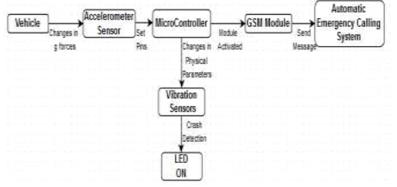

The model presented here involves a collective integration of different types of sensors as well as microcontroller units which acknowledge emergency calling system. This technology includes the benefits of GSM modem used as  
automatic emergency calling system and GPS sensor for location calling. GSM modem requires a SIM card and works with a GSM wireless network. Accelerometer sensors and vibration sensors are collaborated. Accelerometer sensors measure proper acceleration and when at rest on the Earth’s surface quantify an acceleration g=9.81 m/s2 straight upwards. Vibration sensors measure various physical parameters like changes in acceleration, temperature by converting them to electrical signal. During an accident, the changes in g-forces (acceleration) in the vehicle are sensed by the accelerometer sensors. The flags are set on a microcontroller which is a single integrated circuit. It represents the data by setting the appropriate pin of LED. Turned ON LED implies crash detection by vibration sensors.

The estimate of g-forces measured by the accelerometer sensors can be used as a reference to be rated on  
a scale in order to provide an idea about the depth of the accident.

For this purpose, the sensitivity of the accelerometers must be very high and must measure low level accelerations  
precisely from d.c. up to 50Hz (or above). Also, they must be installed with a high positional accuracy. Hence the  
accelerometer sensor module works as an important factor in detection of vehicle accident.

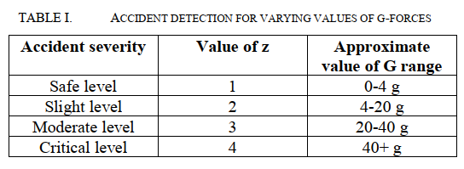

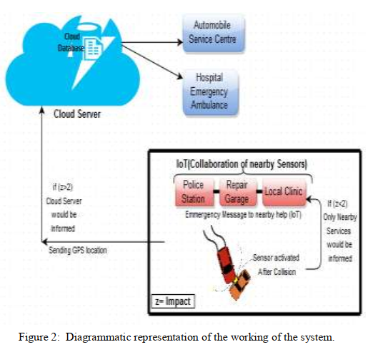

Conclusion:

proposed an intelligent accident detection and safety scheme from the integration of the hyped technology available today, i.e. IoT, Cloud and the Wireless Sensor Network. Given that, the idea could be taken into study using just the GSM modem and required sensors but our aim was to globally inter-connect with the IoT and the cloud because with the use of cloud computing, the higher impact i.e. the emergency situation could be monitored by the cloud server, saving the precious lives.